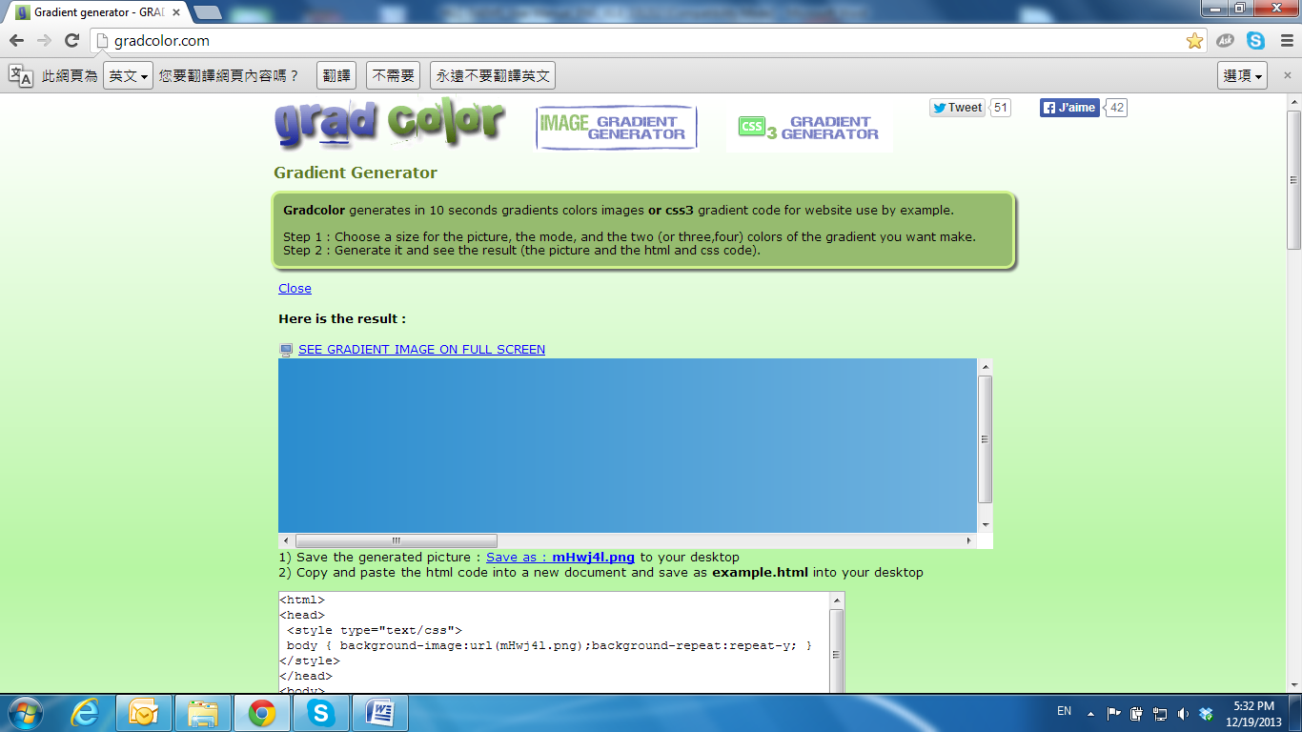
Product Specifications

Main Features:

  - Full HD 1080P Real Time
  - 3D+2D Digital Noise Reduction
  - Digital Wide Dynamic Range
  - Adjustable Shutter Speed
  - Adjustable Sense Up
  - Power over Ethernet
  - H.264/ M-JPEG Compression
  - Micro SD Card Backup (Optional)
  - IK10
  - Support for iPhone/Android/Mac
  - SDK for Software Integration
  - Free Bundle 36 ch Recording Software

Hardware
CPU | Multimedia SoC
RAM | 256MB
Flash | 16MB
Image Sensor | 1 / 2.7” Mega-Pixel CMOS Sensor
Sensitivity | Color : 0.1 Lux (AGC ON)
Lens Type | 2.8mm @ F2.0
View Angle | 111.1°(H)  65.1°(V)
Power over Ethernet | Yes
Audio | G.711(64K) and G.726(32K,24K)  Input : 3.5mm phone jack  Output: 3.5mm phone jack  Support 2-way audio
Video Output | N/A
I/O | 1 DI / 1 DO
Power Consumption | DC 12V Max: 2.40W  PoE Max: 3.36W
Operating Temperature | -10°C ~ 50°C
Dimensions | 80mm (∅) x 67mm (H)
Weight | 340g
Network
Ethernet | 10/ 100 Base-T
Network Protocol | IPv6, IPv4, HTTP, HTTPS, SNMP, QoS/DSCP, Access list, IEEE 802.1X, RTSP, TCP/ IP, UDP, SMTP, FTP, PPPoE, DHCP, DDNS, NTP, UPnP, 3GPP, SAMBA, Bonjour
System
Video Resolution | 1920x1080@30fps, 1280x720@30fps, 640x480@30fps, 320x240@30fps, 176x144@30fps
Video Adjust | Brightness, Contrast, Hue, Saturation, Sharpness, AGC, Shutter Time, Sense-Up, D-WDR, Anti Fog, Lens Distortion Correction, Flip, Mirror, Red Gain and Blue Gain, De-noise
Triple Streaming | Yes
Image Snapshot | Yes
Full Screen Monitoring | Yes
Privacy Mask | Yes, 3 different areas
Compression Format | H.264/ M-JPEG
Video Bitrates Adjust | CBR, VBR
Motion Detection | Yes, 3 different areas
Triggered Action | Mail, FTP, Save to SD card, Samba
Security | Password protection, IP address filtering, HTTPS encrypted data transmission, 802.1X port-based authentication for network protection, QoS/DSCP
Firmware Upgrade | HTTP mode, can be upgraded remotely
Simultaneous Connection | Up to 10
Micro SD Card Management
Recording Trigger | Motion Detection, IP check, Network break down (wire only),Schedule
Video Format | AVI, JPEG
Video Playback | Yes
Delete Files | Yes
Web Browsing Requirement
OS | Windows 7, 2000, XP, 2003, Microsoft IE 6.0 or above, Chrome, Safari, Firefox
Mobile Support | iOS 4.3 or above, Android 1.6 or above.
Hardware Suggested | Intel Dual Core 2.53G  RAM: 1024MB  Graphic card: 128MB

*SPECIFICATIONS ARE SUBJECT TO CHANGE WITHOUT NOTIFICATION.

